Skills checks cover pre-requisite material needed for the first unit of the course, limits. Answer the following questions neatly and completely. Calculators are not allowed.

- Graph the following piecewise function:

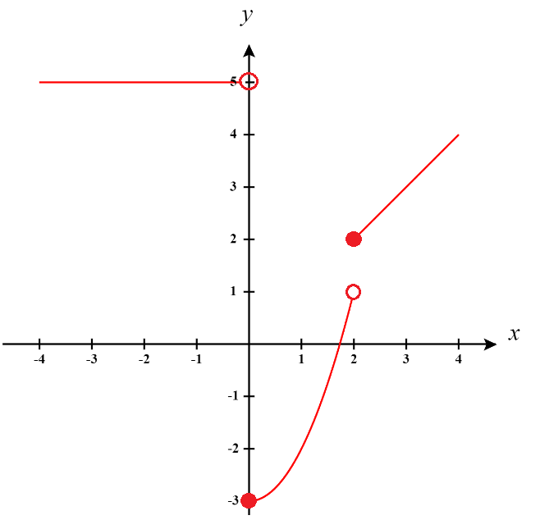

- Graph the following piecewise function:

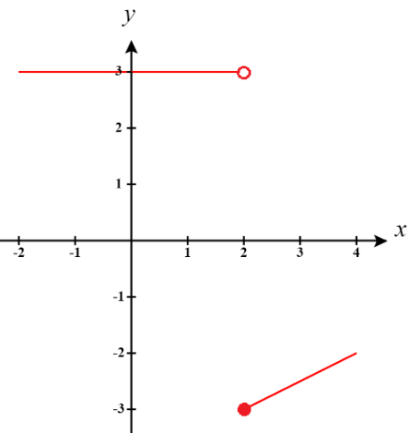

- Graph the following piecewise function:

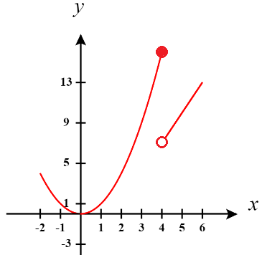

- Complete the following subtraction and fully simplify the result:

- Complete the following addition and fully simplify the result:

- Complete the following subtraction and fully simplify the result:

- Determine the interval communicated by the inequality:

In order for the given statement to be true we know that:

- Determine the interval communicated by the inequality:

In order for the given statement to be true we know that:

- Determine the interval communicated by the inequality:

In order for the given statement to be true we know that:

- Rationalize the denominator of the fraction:

- Rationalize the numerator of the fraction:

- Rationalize the denominator of the fraction:

- Setup and simplify the expression using the function:

- Setup and simplify the expression using the function:

- Setup and simplify the expression using the function:

